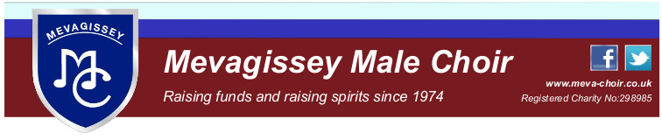

Minutes of Committee Meeting
Zoom on 16th December 2020
1 Present
Nick Nicholls (NN) Chair, Stephen Gibson (SG) Vice Chair, Graham Hoskins (GH) Treasurer, Roger Mitchell (RM), Chris Williams (CW), Humfrey Stobart (HS), Cliff Burnett (CB), David Leeson (DL), Mike Tate (MT), Simon Lawday (SL)
Apologies
Phil Vellenoweth, Rod Richardson
2 Minutes of 21/11 meeting
Thanks to SG for taking minutes. Minutes were agreed.
Minutes were agreed as a record of our last meeting Proposed by DL
Agreed by all
3 Matters arising (if not on agenda)
none
4 Monday’s Zoom practice
NN talked about getting the most out of our zoom meetings. He asked MT to include advice about practising music before practice using the website teach tracks.
5 Almoner report Members roll call (NN)
Iris Hunkin has sadly died following a fall. Jim is still ill in hospital. GA has sent a card
NN has been in contact with Phil Vellenoweth, Cathryn is still poorly. It was agreed that NN and GA would organise some flowers to be sent on behalf of the choir.
NN and RM (MT and SG – baritones) have contacted their section members
6 Treasurer’s report (GH)
Very few transactions. GH report was accepted in full
Honoraria for GW and MF will be increased to the full amount in the new year.
7 CD sales and downloads (CW)
29 Christmas CDs have been sold, 2 downloads, netting over £300 for St Petrocs.
Copies of our CDs have been placed in The Ship Pentewan, The Polgooth Inn and The Fountain.
8 Concerts (CB)
a. Caerhays - We have been invited to sing at a wedding on 29.5.21
It was felt that this was too early for us to be ready to sing in public. DL reminded us that the committee had agreed that it would take two months to be ready to sing in public following the end of singing restrictions due to the pandemic. Committee declined the invitation. CB would inform the groom
b. Birmingham
NN is to write to the Federation as the committee does not feel that the Birmingham concert is viable, e.g. when are we going to learn the songs. We know that the number of singers from Mevagissey has fallen by half, largely due to the change of date.
NN will inform Chris Bale of the committees concerns as this will affect his plans to organise a concert for the choir on the Birmingham trip.
MT asked to have federation response as an agenda item for next month.
9 Christmas Cards and Newsletter (MT)
MT reported that the newsletter had been sent electronically. He has prepared a Christmas card which will put in the envelope for those who get a hard copy.
10 AOB
a. Thanks to Jane Stubberfield who has agreed to allow MT to host the committee meetings on her Zoom account
b. HS asked about fees paid to the church. We agreed to continue as a gesture of our commitment to the community of Mevagissey. It was also noted that the building was still being used to store our grand piano and various Choir property.
c. GH Sponsors are still enjoying advertising on our website. GH and MT will rationalise the sponsors page. We have a few sponsors who didn’t pay their contributions last year.
11 Next meeting 20th January 2021, 7.30
MT will set up a Zoom Meeting

