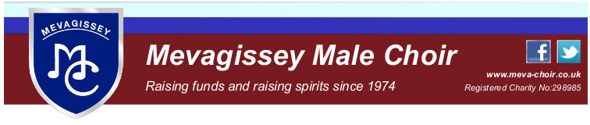
Minutes of Committee Meeting

Wednesday 21st April 2021 at 7pm

on Zoom

Present
Nick Nicholls (NN) Chair, Graham Hoskins (GH) Treasurer, Roger Mitchell (RM), Chris Williams (CW), Humfrey Stobart (HS), Cliff Burnett (CB), David Leeson (DL), Mike Tate (MT), Simon Lawday (SL)
Apologies Phil Vellenoweth, Rod Richardson
In the absence of the Secretary, DL volunteered to take notes.
Minutes of meeting of 17th March
These were agreed to be an accurate record.
Matters arising.
Bursary
NN had contacted Matt Douglas re the Music Bursary, but Matt had not had a lot of contacts with Teachers in the present situation and had said he would make some enquiries. He had not reported back at the time of this meeting. (I suggest we put this on the agenda for our next meeting – again, or it will slip. DL.) Action
Letter to members re Zoom Rehearsals
MT reported that he had had replies to his letter re Monday Zoom rehearsal attendance from two members who had explained their difficulties, which were not all technical.
Quay Concerts
NN reported that he had contacted the Harbour Trustees and the Social Club re arrangements for Quay Concerts. Our proffered cheque has been cashed, but he has not had any reply and will follow it up. Action
Minack Theatre
MT has been in contact with the Minack who have asked if we would be prepared to perform on a Friday evening, and if we would be interested in slots later in the year than May. The meeting was not in favour of Fridays, but may be interested in later dates, excluding August. MT to convey this to the Minack. Action
Agenda Item 4. Almoner’s report
Graham Alee reported that he had sent a sympathy card to the Foard family following Shiela’s death.
The health of another member was discussed, but as he did not want his situation to become general knowledge, his wishes were respected, though it was agreed that NN would inform our Almoner. Action
Agenda Item 5. Treasurer’s Report. (previously circulated)
There was little to report beyond two donations which were not going to cover our expenditure for the month, but the committee saw no cause for concern. The Treasurer apologised for omitting details of commitments from his report but informed the committee that they remained the same as the previous month.
Agenda Item 6. Zoom Rehearsals
MT’s letter had already been discussed, but the committee were more than satisfied with the contribution these were making to the health of the choir, and MT was thanked for his contribution to facilitating them.
Agenda Item 7. Concert update.
CB had nothing to report and reminded the meeting that we were waiting for government guidance on when we could start singing together. A general discussion followed a query by CW as to whether we would be singing on the quay. The consensus was that we should remain optimistic and continue rehearsing pieces that we could use on the Quay.
Agenda Item 8. CD sales and downloads
CW reported that only 2 CDs had been sold and posted to a buyer in St. Katherines, Ontario. (30 years after the Choir opened their Wine Festival!)
Agenda Item 9. Pub CDs.
MT reported that he had now received the ones from The Polgooth Inn, so only those from the Fountain were now outstanding, and the committee agreed that this was not a cause for concern.
Agenda Item 10. Photo Library.
MT explained to the committee that he and Simon Gibson were in the process of setting this up, in Mike’s icloud account. HS queried the use of Mike’s account as an on-going arrangement, and MT pointed out that the choir could have its own account at a price. The issue was not explored further.
Agenda Item 11. Choir re-union.
To be kept on the agenda
Agenda Item 12. A.O.B.
SL raised the issue of renewing Executive members Membership of Mevagissey Social Club. RM said he would contact the Club after May 17th. Action
DL aired the possibility of continuing with Zoom committees after lockdown, and it was decided to make it an agenda item for the next meeting. Action
Agenda Item 13. Date of next meeting.
Wednesday May 19th. At 19.00.
The meeting closed at 19.46.

